What is Cloud Computing
The term cloud refers to a network or the internet. It is a technology that uses remote servers on the internet to store, manage, and access data online rather than local drives.
Cloud Computing Architecture
Cloud computing architecture is divided into the following two parts -
- Front End
- Back End
Front End
- The front end is used by the client. It contains client-side interfaces and applications that are required to access the cloud computing platforms.
- The front end includes web servers (including Chrome, Firefox, internet explorer, etc.), tablets, and mobile devices.
Back End
- The back end is used by the service provider.
- It includes a huge amount of data storage, security mechanism, virtual machines, deploying models, servers, traffic control mechanisms, etc.
Note: Both front end and back end are connected to others through a network, generally using the internet connection.
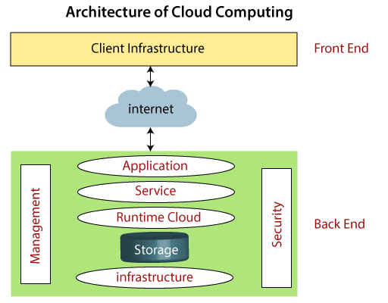

Benefits of Cloud Computing
- Lower Cost
- Lower Risks
- Higher profit margins
- Higher security
- Collaborative
- Better Performance
- Reliability
- Simplicity
- Scalability
Deployment Models of Cloud // Types of Clouds
There are the following 4 types of cloud that you can deploy according to the organization's needs
Public Cloud
- Public cloud is open to all to store and access information via the Internet using the pay-per-usage method.
- Example: Amazon elastic compute cloud (EC2), IBM Smart Cloud Enterprise, Microsoft, Google App Engine, Windows Azure Services Platform.
Private Cloud
- Private cloud is also known as an internal cloud or corporate cloud. It is used by organizations to build and manage their own data centre’s internally or by the third party.
- Examples: VMware vSphere, OpenStack, Microsoft Azure Stack, Oracle Cloud at Customer, and IBM Cloud Private.
Hybrid Cloud
- Hybrid Cloud is a combination of the public cloud and the private cloud.
- Example: Google Application Suite (Gmail, Google Apps, and Google Drive), Office 365 (MS Office on the Web and One Drive), Amazon Web Services.
Community Cloud
- Community cloud allows systems and services to be accessible by a group of several organizations to share the information between the organization and a specific community.
- It is owned, managed, and operated by one or more organizations in the community, a third party, or a combination of them.
- Example: Health Care community cloud

Cloud Computing Services
There are the following three types of cloud service models -
- Infrastructure as a Service (IaaS)
- Platform as a Service (PaaS)
- Software as a Service (SaaS)
Infrastructure as a Service (IaaS)
IaaS is also known as Hardware as a Service (HaaS). It is a computing infrastructure managed over the internet.
Characteristics of IaaS
- Resources are available as a service
- Services are highly scalable
Example: Amazon Web Services (AWS), Microsoft Azure, Google Compute Engine (GCE)
Platform as a Service (PaaS)
PaaS cloud computing platform is created for the programmer to develop, test, run, and manage the applications.
Characteristics of PaaS
- Accessible to various users via the same development application.
- Integrates with web services and databases.
Example: Windows Azure, Heroku, Force.com, Google App Engine
Software as a Service (SaaS)
SaaS is also known as "on-demand software". It is a software in which the applications are hosted by a cloud service provider. Users can access these applications with the help of internet connection and web browser.
Characteristics of SaaS
- Managed from a central location
- Users are not responsible for hardware and software updates. Updates are applied automatically.
- The services are purchased on the pay-as-per-use basis
Example: Google Apps, Salesforce, Cisco Webex, Slack.

